-- Database: lab6

-- DROP DATABASE lab6;

/////////1

CREATE DATABASE lab6

WITH

OWNER = postgres

ENCODING = 'UTF8'

LC_COLLATE = 'Kazakh_Kazakhstan.utf8'

LC_CTYPE = 'Kazakh_Kazakhstan.utf8'

TABLESPACE = pg_default

CONNECTION LIMIT = -1;

CREATE TABLE Students(

stud_id int PRIMARY KEY,

fname varchar(20),

lname varchar(20)

);

CREATE TABLE Departments(

dep_id int PRIMARY KEY,

name varchar(10)

);

CREATE TABLE Teachers(

teach_id int PRIMARY KEY,

fname varchar(20),

lname varchar(20),

dep_id int REFERENCES Departments(dep_id)

);

INSERT INTO Students VALUES (1,'A','A'), (2,'B','B');

INSERT INTO Departments VALUES (1,'AAA'), (2,'BBB');

INSERT INTO Teachers VALUES (1,'B','B', 2), (2,'C','C', 2), (3,'D','D', null);

///**For check that database successful created.**

Select * FROM Students;

Select * FROM Teachers;

select * from Departments;

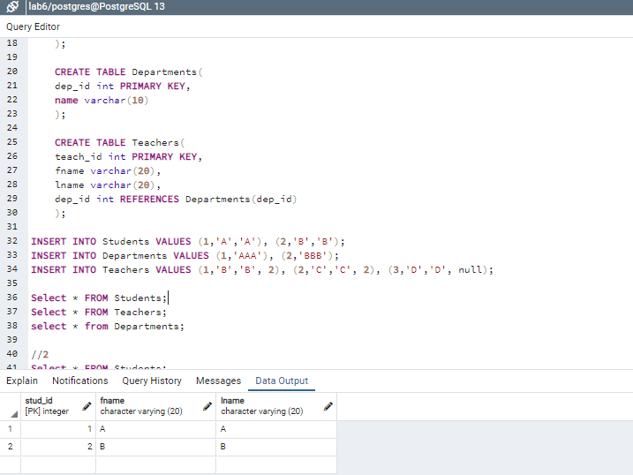

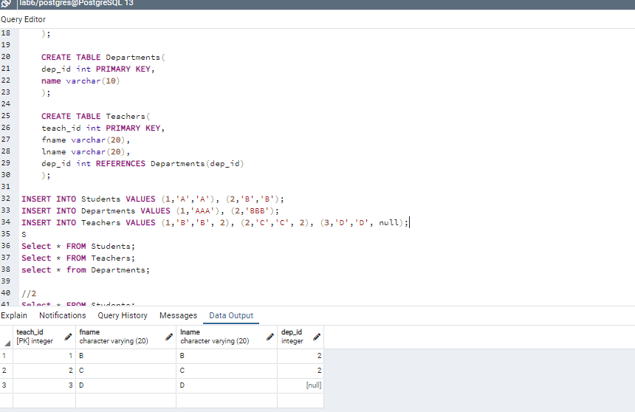

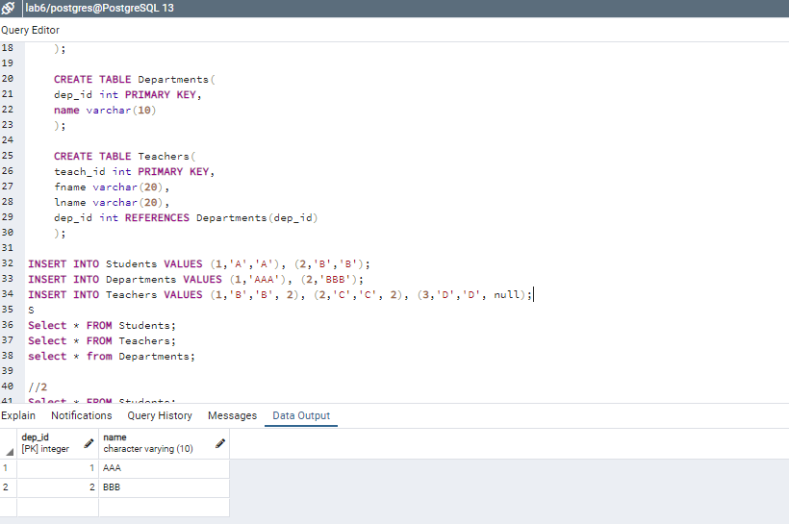

//2

SELECT lname FROM Students;

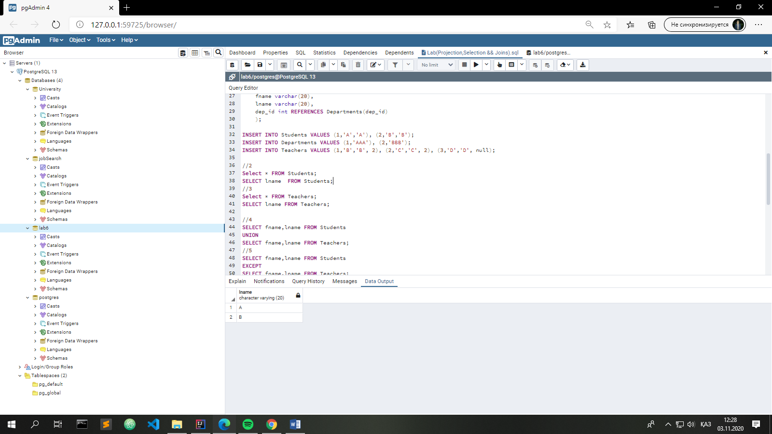

//3

SELECT lname FROM Teachers;

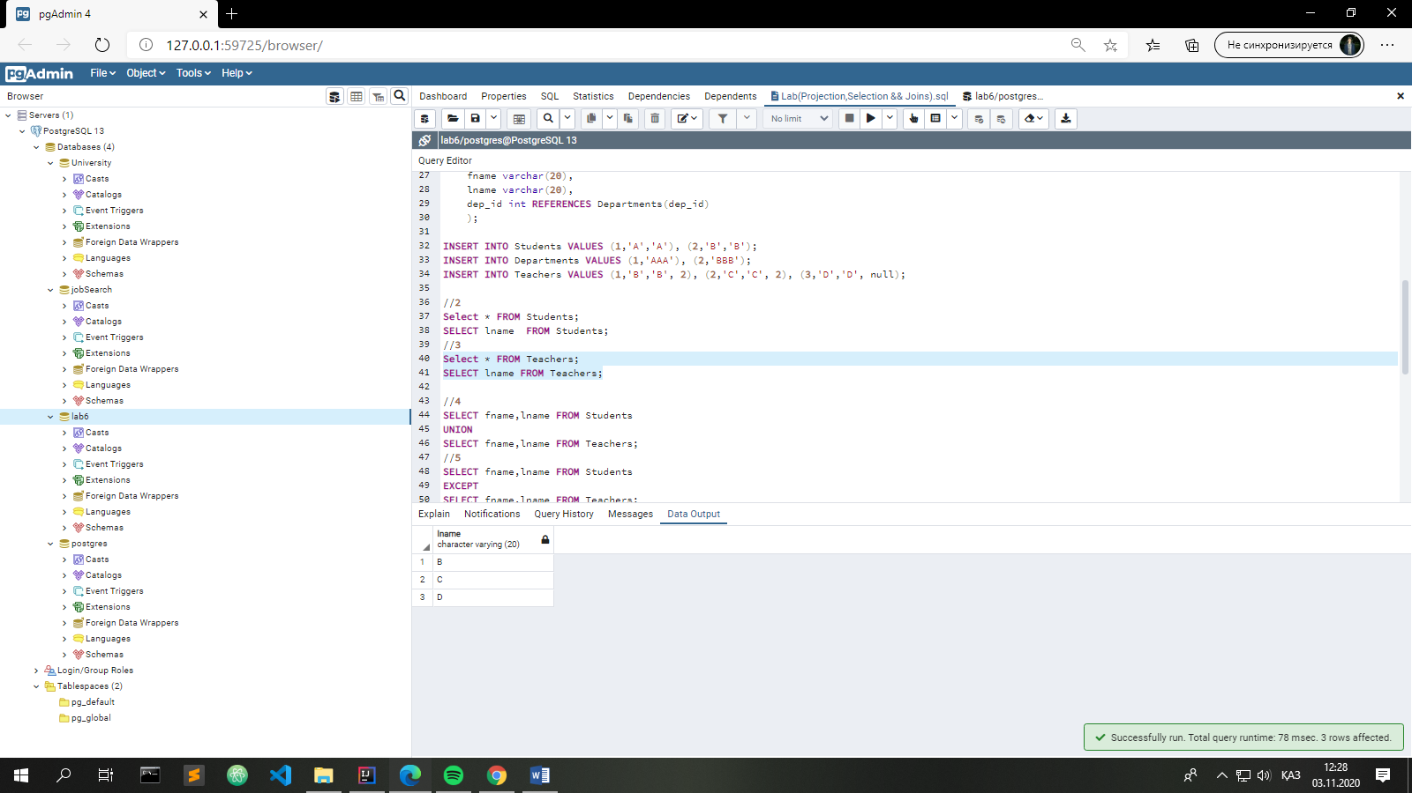

//4

SELECT fname,lname FROM Students

UNION

SELECT fname,lname FROM Teachers;

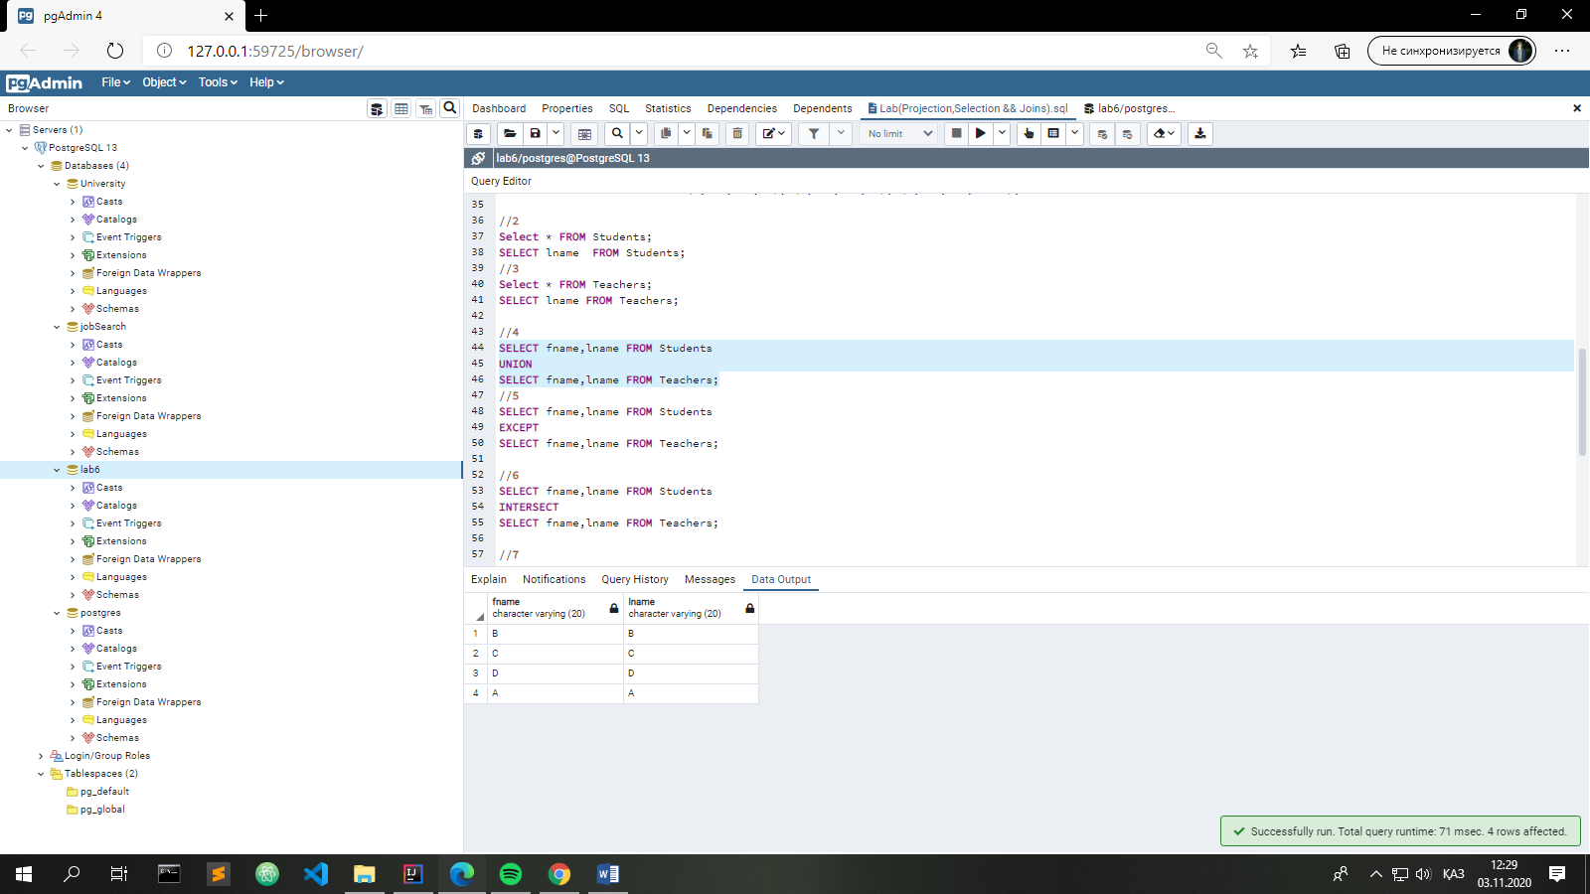

//5

SELECT fname,lname FROM Students

EXCEPT

SELECT fname,lname FROM Teachers;

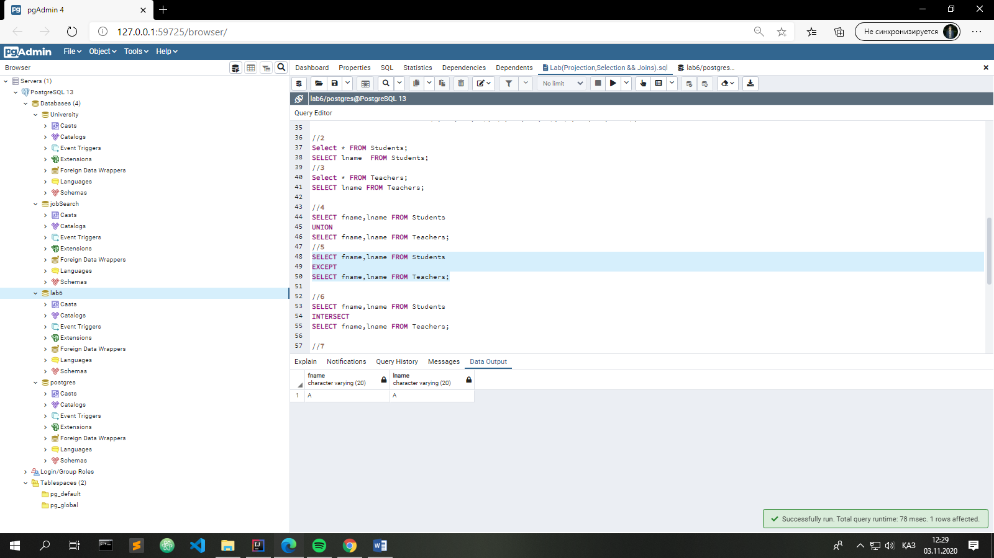

//6

SELECT fname,lname FROM Students

INTERSECT

SELECT fname,lname FROM Teachers;

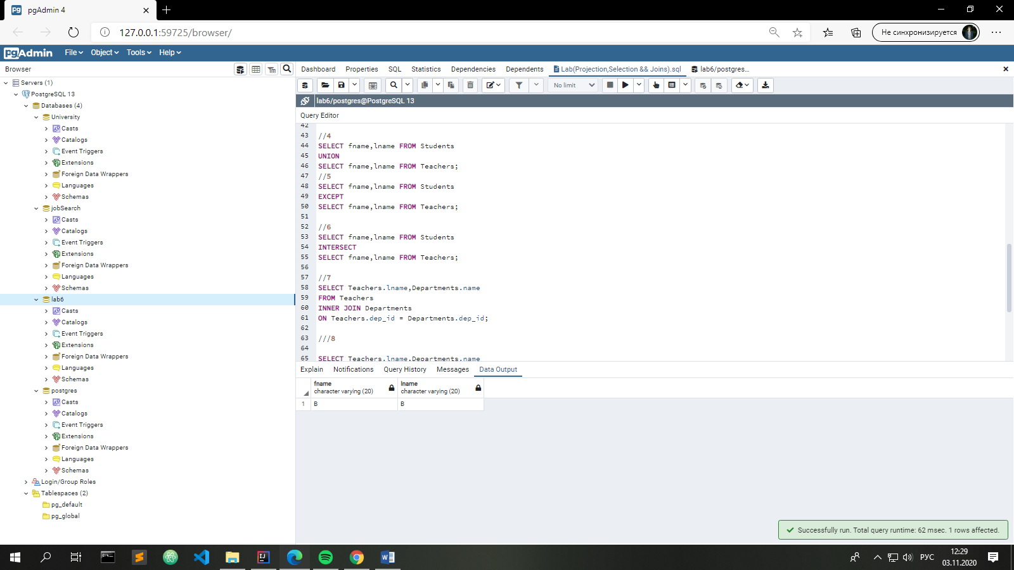

//7

SELECT Teachers.lname,Departments.name

FROM Teachers

INNER JOIN Departments

ON Teachers.dep_id = Departments.dep_id;

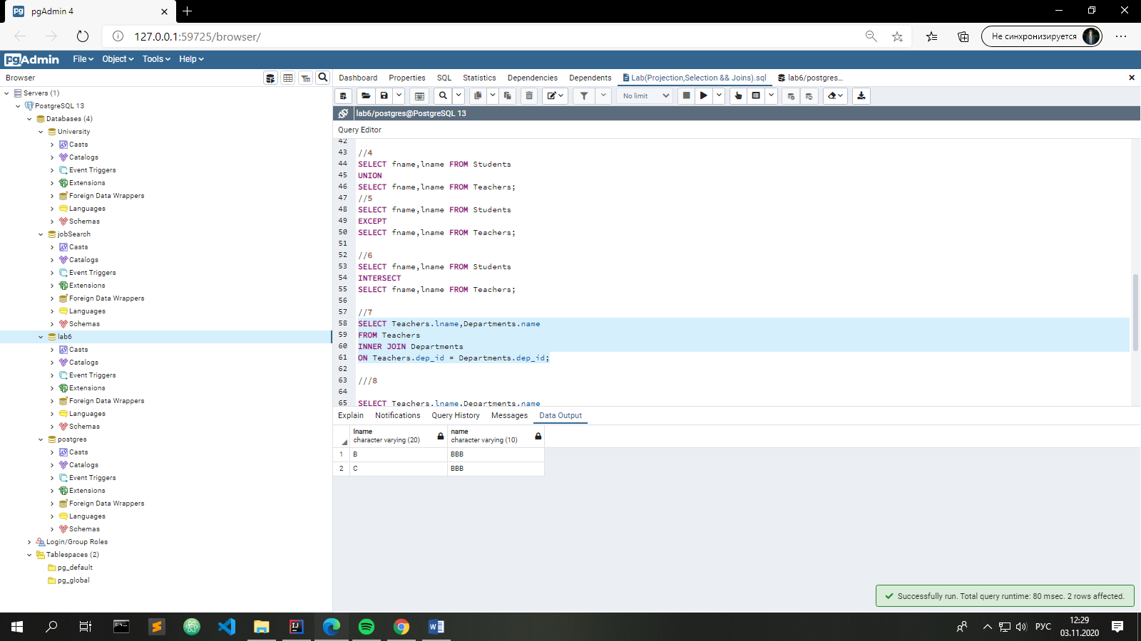

//8

SELECT Teachers.lname,Departments.name

FROM Teachers

LEFT JOIN Departments

ON Teachers.dep_id = Departments.dep_id;

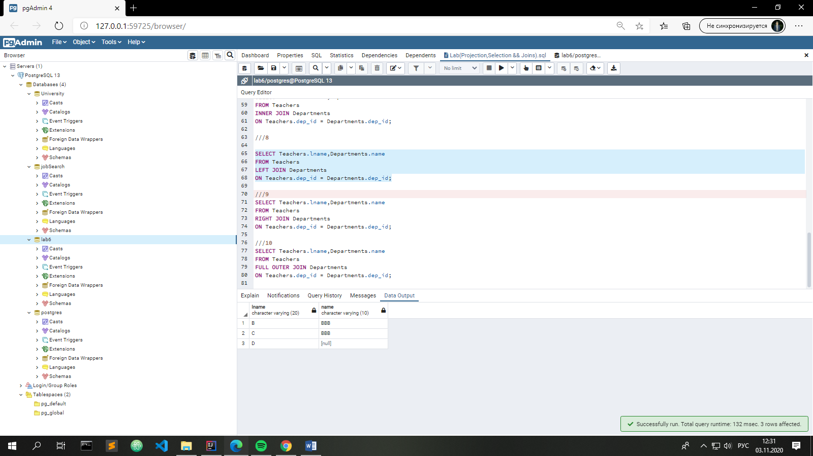

///9

SELECT Teachers.lname,Departments.name

FROM Teachers

RIGHT JOIN Departments

ON Teachers.dep_id = Departments.dep_id;



///10

SELECT Teachers.lname,Departments.name

FROM Teachers

FULL OUTER JOIN Departments

ON Teachers.dep_id = Departments.dep_id;

